SIMATS ENGINEERING
ASSESSMENT TOOL I – EXPERIMENTS
Course: Data Handling and  Visualization | Code: DSA0603 | CO: CO3
Duration: 120 min | Total Marks: 100 | Reg No : 192524029  Name:KAILASH M

COURSE OUTCOME COVERED
CO3: Analyze time-series data, trends, associations, and uncertainty through appropriate visualization methods. (BL4) Activity Tool : Experiments
Weightage: 20%
Code of Conduct:
I KAILASH M (192524029) certify that this submission is my original work and that I have adhered to the guidelines specified for this assessment. I understand that any violation of academic integrity rules will result in disciplinary action.
Signature of the student:KAILASH M
Criteria | Understanding of Concepts  25% | Experimental  Design  30% | Use of Tools  20% | Analysis of  Results  15% | Documents  10% | Total
Q1
Q2
Q3
Q4
Q5

DSA06 – Data Handling and Visualization | Assessment Tool: Experiment
DSA06 – DATA HANDLING AND VISUALIZATION
CO3_AT1_Assessment Tool: EXPERIMENT

Q1 – ECDF and Normal Q-Q Plot
# Q1 Distribution Diagnosis

library(ggplot2)

data <- c(
118, 121, 125, 127, 129, 131, 134, 136, 138, 141,
144, 147, 151, 156, 162, 171, 184, 205, 249, 318
)

df <- data.frame(response_time = data)

# ECDF Plot
ggplot(df, aes(x = response_time)) +
stat_ecdf() +
labs(
title = "ECDF of Response Time",
x = "Response Time (ms)",
y = "ECDF"
) +
theme_minimal()

# Normal Q-Q Plot
ggplot(df, aes(sample = response_time)) +
stat_qq() +
stat_qq_line() +
labs(
title = "Normal Q-Q Plot",
x = "Theoretical Quantiles",
y = "Sample Quantiles"
) +
theme_minimal()

# Mean and standard deviation
mean(data)
sd(data)

# 95th percentile
quantile(data, 0.95)

Q1 Result
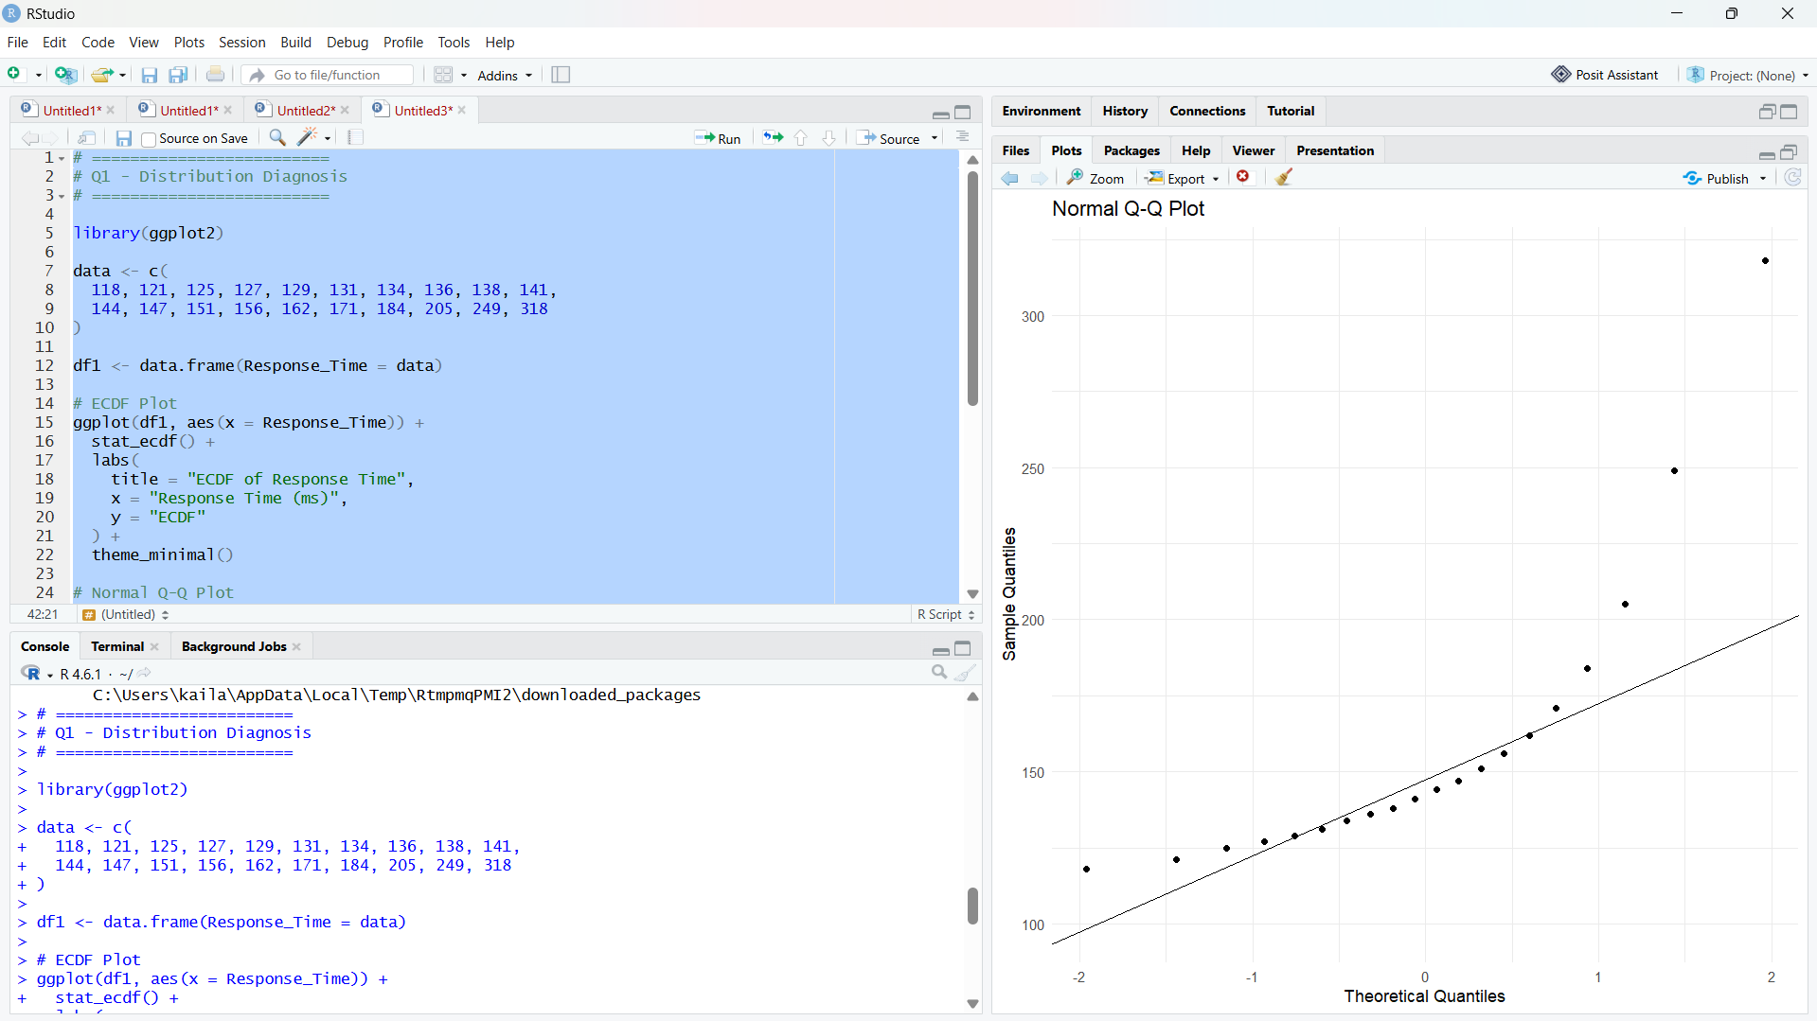The values 205, 249 and 318 ms are unusually high. Therefore, percentile-based limits are more suitable than mean ± standard deviation limits.

Q2 – Comparing Distributions and Bean Plot
# Q2 Comparing Production Lines

library(ggplot2)
library(tidyr)

L1 <- c(42, 44, 45, 46, 47, 48, 49, 50, 51, 53)
L2 <- c(38, 41, 44, 47, 50, 53, 56, 59, 62, 65)
L3 <- c(45, 46, 46, 47, 47, 48, 48, 49, 49, 50)
L4 <- c(40, 41, 42, 43, 44, 45, 48, 55, 61, 72)

df <- data.frame(
L1 = L1,
L2 = L2,
L3 = L3,
L4 = L4
)

long_data <- pivot_longer(
df,
cols = everything(),
names_to = "Line",
values_to = "Cycle_Time"
)

# Box Plot
ggplot(long_data, aes(x = Line, y = Cycle_Time)) +
geom_boxplot() +
labs(
title = "Cycle Time Distribution",
x = "Production Line",
y = "Cycle Time (minutes)"
) +
theme_minimal()

# Violin Plot - equivalent to bean plot
ggplot(long_data, aes(x = Line, y = Cycle_Time)) +
geom_violin(trim = FALSE) +
geom_jitter(width = 0.08, size = 2) +
labs(
title = "Bean Plot Equivalent - Production Lines",
x = "Production Line",
y = "Cycle Time (minutes)"
) +
theme_minimal()

# Mean of each line
aggregate(Cycle_Time ~ Line, long_data, mean)

# Standard deviation of each line
aggregate(Cycle_Time ~ Line, long_data, sd)

# Range of each line
aggregate(Cycle_Time ~ Line, long_data, range)

Q2 Result

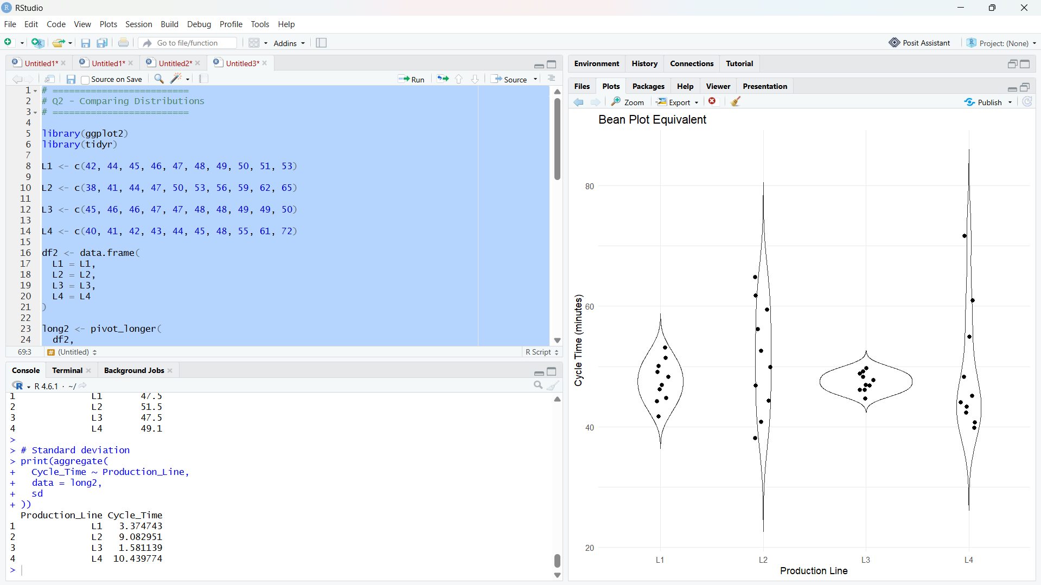
- L4 has the greatest variability.
- L3 has the most concentrated distribution.
- Comparing only means is insufficient because mean does not show spread, skewness or extreme values.

Q3 – Proportion Visualization
# Q3 Proportion Visualization

library(ggplot2)
library(tidyr)

df <- data.frame(
Department = c("CSE", "ECE", "IT"),
Online = c(52, 45, 30),
Blended = c(28, 35, 40),
Face_to_Face = c(20, 20, 30)
)

long_data <- pivot_longer(
df,
cols = c(Online, Blended, Face_to_Face),
names_to = "Learning_Mode",
values_to = "Percentage"
)

# Side-by-side Bar Chart
ggplot(long_data,
aes(x = Department, y = Percentage, fill = Learning_Mode)) +
geom_bar(
stat = "identity",
position = "dodge"
) +
labs(
title = "Preferred Learning Mode by Department",
x = "Department",
y = "Percentage"
) +
theme_minimal()

# 100% Stacked Bar Chart
ggplot(long_data,
aes(x = Department, y = Percentage, fill = Learning_Mode)) +
geom_bar(
stat = "identity",
position = "fill"
) +
scale_y_continuous(labels = scales::percent) +
labs(
title = "100% Stacked Bar Chart",
x = "Department",
y = "Percentage"
) +
theme_minimal()

Q3 Result

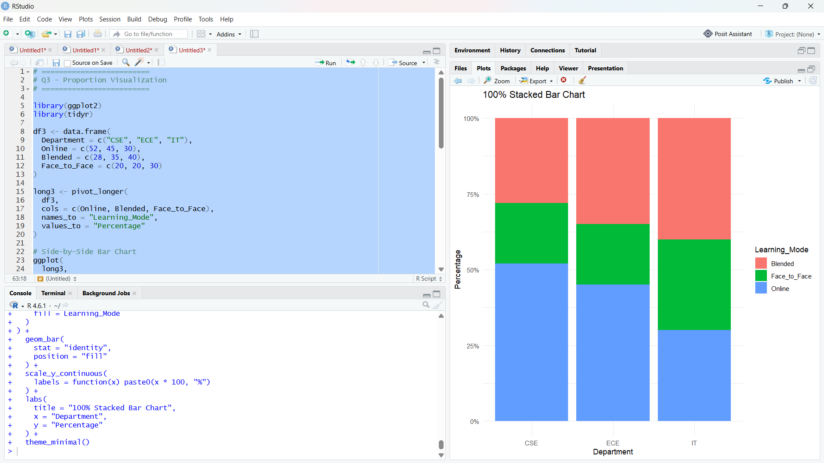
The side-by-side bar chart is better for comparing individual proportions because all bars start from the same baseline.
Separate pie charts are less effective because comparing angles and areas between multiple pies is difficult.
A misleading design choice is starting the y-axis above zero, which can exaggerate small differences.

Q4 – Treemap and Sunburst
# Q4 Treemap and Sunburst

install.packages("treemapify")
install.packages("plotly")

library(ggplot2)
library(treemapify)
library(plotly)

df <- data.frame(
Category = c(
"Electronics", "Electronics", "Electronics",
"Home", "Home", "Home",
"Fashion", "Fashion", "Fashion"
),
Subcategory = c(
"Mobiles", "Laptops", "Accessories",
"Furniture", "Appliances", "Decor",
"Men", "Women", "Kids"
),
Revenue = c(
24, 18, 8,
14, 10, 6,
7, 8, 5
)
)

# Treemap
ggplot(
df,
aes(
area = Revenue,
fill = Category,
label = paste(Subcategory, "\n₹", Revenue, " lakh")
)
) +
geom_treemap() +
geom_treemap_text() +
labs(
title = "Annual Revenue Treemap"
) +
theme_minimal()

Sunburst
# Sunburst Chart

fig <- plot_ly(
df,
ids = ~Subcategory,
labels = ~Subcategory,
parents = ~Category,
values = ~Revenue,
type = "sunburst"
)

fig <- fig %>%
layout(
title = "Annual Revenue Sunburst Chart"
)

fig

Largest Category
# Calculate category totals

category_total <- aggregate(
Revenue ~ Category,
data = df,
sum
)

print(category_total)

# Percentage of total revenue

total_revenue <- sum(df$Revenue)

category_total$Percentage <-
category_total$Revenue / total_revenue * 100

print(category_total)

Expected Result

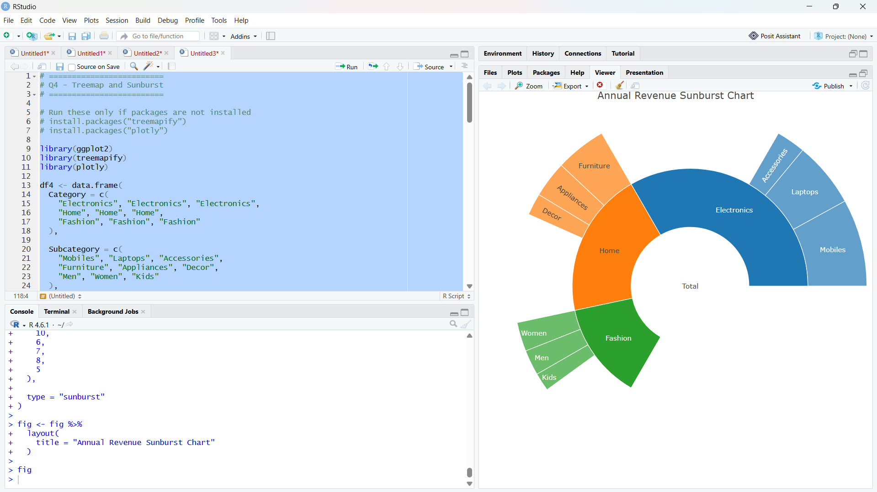
Electronics = ₹50 lakh
Home = ₹30 lakh
Fashion = ₹20 lakh
The given subcategory data totals ₹100 lakh, although the scenario states total annual revenue of ₹1.2 crore = ₹120 lakh.
Using the provided table values, Electronics represents:
50 / 100 × 100 = 50%
If the intended total is ₹120 lakh, Electronics would be:
50 / 120 × 100 = 41.67%
So mention this discrepancy in your report.

Q5 – Sankey Diagram and Parallel Sets
First install the packages:
install.packages("networkD3")
install.packages("ggalluvial")

Sankey Diagram
# Q5 Sankey Diagram

library(networkD3)

nodes <- data.frame(
name = c(
"Residential",
"Suburban",
"Rural",
"Bus",
"Train",
"Central",
"Industrial"
)
)

links <- data.frame(
source = c(
0, 0, 0, 0,
1, 1, 1, 1,
2, 2, 2, 2,
3, 3, 4, 4
),

target = c(
3, 3, 4, 4,
3, 3, 4, 4,
3, 3, 4, 4,
5, 6, 5, 6
),

value = c(
35, 15, 25, 10,
20, 10, 30, 15,
12, 8, 10, 10,
67, 33, 77, 35
)
)

sankeyNetwork(
Links = links,
Nodes = nodes,
Source = "source",
Target = "target",
Value = "value",
NodeID = "name",
fontSize = 14,
nodeWidth = 30
)

Parallel Sets
# Parallel Sets
"Residential", "Residential",
"Residential", "Residential",
"Suburban", "Suburban",
"Suburban", "Suburban",
"Rural", "Rural",
"Rural", "Rural"
),

Mode = c(
"Bus", "Bus",
"Train", "Train",
"Bus", "Bus",
"Train", "Train",
"Bus", "Bus",
"Train", "Train"
),

Destination = c(
"Central", "Industrial",
"Central", "Industrial",
"Central", "Industrial",
"Central", "Industrial",
"Central", "Industrial",
"Central", "Industrial"
),

Commuters = c(
35, 15,
25, 10,
20, 10,
30, 15,
12, 8,
10, 10
)
)

ggplot(
df,
aes(
axis1 = Origin,
axis2 = Mode,
axis3 = Destination,
y = Commuters
)
) +
geom_alluvium(aes(fill = Mode)) +
geom_stratum() +
geom_text(
stat = "stratum",
aes(label = after_stat(stratum))
) +
scale_x_discrete(
limits = c("Origin", "Mode", "Destination")
) +
labs(
title = "Parallel Sets of Commuter Flows",
x = "",
y = "Number of Commuters"
) +
theme_minimal()

Q5 Calculations
# Total commuters
sum(df$Commuters)

# Largest individual flow
df[which.max(df$Commuters), ]

# Total commuters by mode
aggregate(Commuters ~ Mode, df, sum)

# Total commuters by destination
aggregate(Commuters ~ Destination, df, sum)

# Destination percentage
destination_total <- aggregate(
Commuters ~ Destination,
df,
sum
)

destination_total$Percentage <-
destination_total$Commuters /
sum(destination_total$Commuters) * 100

print(destination_total)

Expected Q5 Result

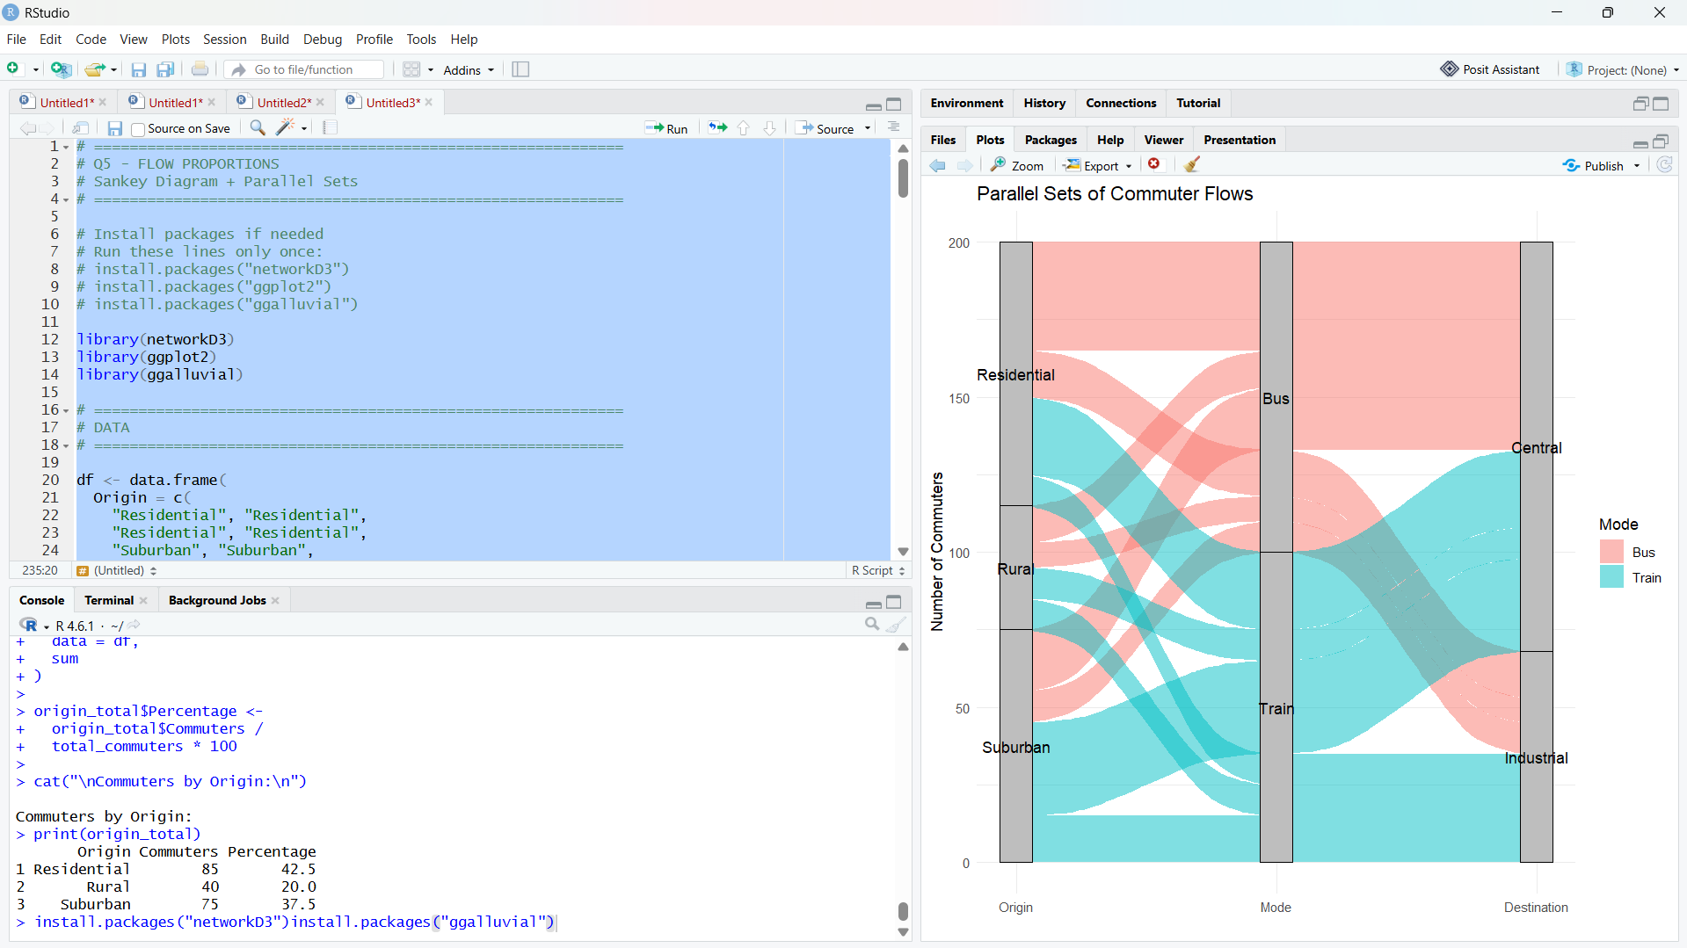
Total commuters = 200

Largest flow:
Residential → Bus → Central = 35 commuters

Bus = 100 commuters = 50%
Train = 100 commuters = 50%

Central = 132 commuters = 66%
Industrial = 68 commuters = 34%
Suggested Evaluation Rubric – Experiment
Criterion | Excellent (4) | Good (3) | Satisfactory (2) | Needs Improvement (1)
Data preparation | Correct and complete | Minor issue | Several issues | Incorrect/incomplete
Visualization choice | Highly appropriate  and justified | Appropriate | Partially appropriate | Poor choice
Technical execution | Accurate and clear | Mostly accurate | Some errors | Major errors
Interpretation | Insightful and  evidence-based | Correct | Basic | Incorrect/unsupported
Misleading-design  analysis | Bias clearly identified and explained | Bias identified | Limited explanation | Not identified

Suggested marks: 20 marks per question; 100 marks total. Level: Competitive / advanced undergraduate.
DSA06 – Data Handling and Visualization | Assessment Tool: Experiment

